Simulation results:

Input entered:

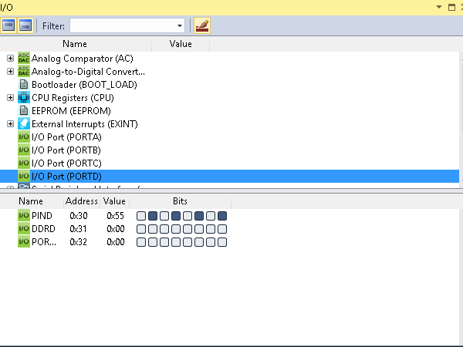

Copied number to portb:

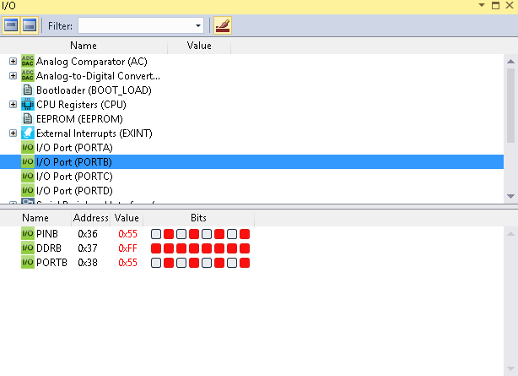

Entered number is LESS:

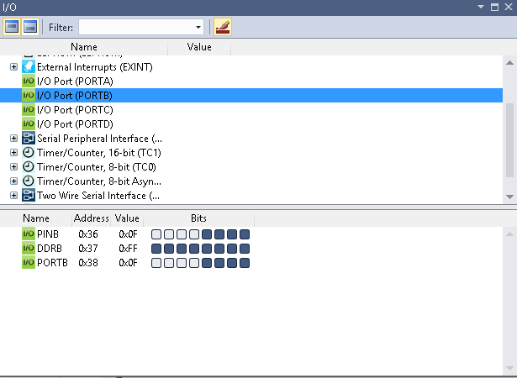

The enterd number by the user is the small as the 1st user so the 0-4 glowing.And if user enters bigger number then the 4-7 glows and if equal then all glows.